Kaizen App – Data Model & API Design
Oct 27, 2026 · @BG

1. Entity overview
The model has 37 tables in 10 groups (email tables in section 9); the picture shows the main ones (planning tables unit_plan, audit_plan, phase_template are in section 2). Every business record links to an area or a project, and both link to a unit, which is what the data-scope check filters on. The → notes are foreign keys.
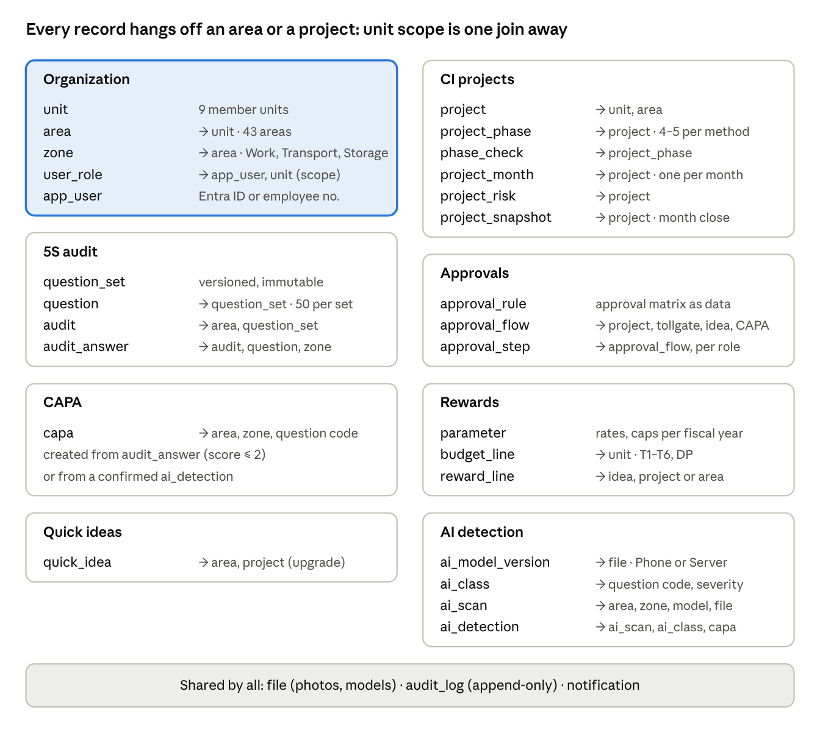
entity overview · 8 domains, 30 tables
Polymorphic links (approval_flow.subject, reward_line.source, capa.source) store *_type + *_id and are checked in the service layer; all other links are real foreign keys.

2. Table definitions
Conventions for every table: id UUID primary key, created_at, created_by, updated_at, updated_by, soft delete deleted_at. Money in VND as bigint; percentages as numeric(6,4) (0.8 = 80%); months as char(7) YYYY-MM. Business codes (5S-2610-ATN-KV02, PH-041, CI-2627-008) are unique, human-readable and separate from id.

Organization and users
Table | Field | Type | Rule
unit | code | varchar(10) | Unique: TTCA, KSK, TTCS, ATN, NHS, PRS, GLS, TTNĐ, VP
unit | name, staff_count, saving_plan_vnd | text, int, bigint | Plan per fiscal year lives in unit_plan
unit_plan | unit_id, fiscal_year, saving_plan_vnd, budget lines | FK, char(9), bigint | 2026-2027; one row per unit and year
area | code, unit_id, name, department, area_type, owner_user_id | varchar(20), FK, text, text, enum, FK | ATN-KV02; type decides question applicability
zone | code, area_id, name, zone_type | varchar(24), FK, text, enum | ATN-KV02-Z03; type Work, Transport, Storage
app_user | entra_oid, email, full_name, employee_no, pin_hash | uuid, text, text, text, text | Office staff via Entra ID; shop floor via employee no + PIN
user_role | user_id, role, unit_id | FK, enum, FK nullable | unit_id required for TEAM_LEAD, DEPT_HEAD, PLANT_DIR; null = all units

5S audit and CAPA
Table | Field | Type | Rule
question_set | version, valid_from | int, date | Published sets are immutable; audits point to a version
question | set_id, code, s, clause, question_text, evidence_hint, methods, applies_to, sort | FK, varchar(8), enum S1–S5, text, text, text, text[], enum, int | S2.06; method Q, P, H, T; applies General, Production, Office
audit_plan | area_id, month, lead_user_id, audit_type | FK, char(7), FK, enum | One per area and month
audit | code, area_id, audit_date, audit_type, lead_user_id, members, area_rep, question_set_id, status | varchar(24), FK, date, enum, FK, text, text, FK, enum | Status Draft, Submitted
audit | pct_s1 … pct_s5, pct_total, conclusion, maturity_level, count_ncl, count_ncn, count_obs, count_ofi | numeric, enum, int, int | Computed on submit, stored for reports
audit_answer | audit_id, question_id, score, finding, zone_id, photo_id, ai_scan_id | FK, FK, smallint null, text, FK, FK, FK | score 0–4 or null = N/A; finding required when score ≤ 2
capa | code, source_type, source_id, area_id, zone_id, question_code, finding_class, description, why_1 … why_5, action, owner_user_id, due_date, done_date, verified_at, verified_by, status | varchar(10), enum, uuid, FK, FK, varchar(8), enum, text, text, text, FK, date, date, timestamptz, FK, enum | Source Audit or AI; before_photo_id, after_photo_id FKs to file

Quick ideas
Table | Field | Type | Rule
quick_idea | code, area_id, author_user_id, author_name, s, problem, idea, benefits, self_implemented | varchar(10), FK, FK null, text, enum, text, text, enum[], bool | QI-001; author_name for staff without login
quick_idea | why_text, data_before, data_after, standard_type, idea_level, status, kaizen_code, project_id, is_kaizen_of_month | text, text, text, enum, smallint, enum, varchar(20), FK, bool | Level computed by the server; before_photo_id, after_photo_id

CI projects
Table | Field | Type | Rule
project | code, name, method, domain, unit_id, area_id, leader_user_id, members, problem, goal | varchar(12), text, enum, enum null, FK, FK null, FK, text, text, text | CI-2627-008; method PDCA, DMAIC, RD
project | kpi_name, kpi_unit, kpi_baseline, kpi_target, has_hard_saving, saving_plan_vnd, investment_vnd | text, text, numeric, numeric, bool, bigint, bigint | investment = BAC for R&D
project | benefit_vnd, opex_vnd, eval_years, discount_rate, fte_plan | bigint, bigint, smallint, numeric, numeric | Defaults 3 years, 10%
project | start_date, end_date, go_live_month, current_phase, approval_status, accepted_at, acceptance_score, s_confirmed_vnd, sustained_at, closed_at | date, date, char(7), smallint, enum, date, smallint, bigint, date, date | Approval chain stored on the project at submit
project_phase | project_id, seq, name, due_date, passed_at | FK, smallint, text, date, date | Generated from method on approval
phase_check | phase_id, item_text, checked, checked_by, checked_at | FK, text, bool, FK, timestamptz | Items copied from phase_template
project_month | project_id, month, kpi_actual, saving_vnd, cost_vnd, pct_complete, labour_hours, overtime_hours, saving_confirmed_by, locked | FK, char(7), numeric, bigint, bigint, numeric, numeric, numeric, FK, bool | Unique (project, month); locked at month close
project_risk | project_id, title, level, status | FK, text, enum, enum | Level High, Medium, Low
project_snapshot | project_id, month, cum_saving, run_rate, pv, ev, ac, cpi, spi, eac, schedule_progress, quality_score | FK, char(7), bigint … numeric | Written by month-close job

Approvals
Table | Field | Type | Rule
approval_flow | subject_type, subject_id, unit_id, phase_seq, status, submitted_at, submitted_by, round | enum, uuid, smallint null, enum, timestamptz, FK, smallint | Subject Project, Tollgate, QuickIdea, Capa; round +1 on each resubmission
approval_step | flow_id, seq, role, due_at, decision, decided_by, decided_at, comment | FK, smallint, enum, timestamptz, enum, FK, timestamptz, text | Decision Pending, Approved, ChangesRequested
approval_rule | subject_type, method, min_investment, max_investment, phase_name, has_hard_saving, roles, sla_days, valid_from | enum, enum, bigint, bigint, text, bool, enum[], smallint, date | The approval matrix as data

Rewards and parameters
Table | Field | Type | Rule
parameter | key, fiscal_year, value_json | text, char(9), jsonb | e.g. t3.rate 0.04, t3.cap_vnd 195000000, fte.hours_per_month 312
budget_line | fiscal_year, unit_id, line, fund, amount_vnd | char(9), FK null, enum, enum, bigint | Lines T1–T6, DP; funds A, B, C
reward_line | line, fiscal_year, period, unit_id, person_user_id, person_name, source_type, source_id, base_vnd, factor, amount_vnd, status, approved_by, paid_period | enum, char(9), varchar(7), FK, FK null, text, enum, uuid, bigint, numeric, bigint, enum, FK, char(7) | Status Pending, Approved, Exported, Cancelled; calc_note text explains the formula used

AI detection
Table | Field | Type | Rule
ai_class | class_index, key, name_vi, s_group, severity, question_code, is_hazard, model_version_id | int, text, text, enum, enum, varchar(8), bool, FK | 17 classes in v0.1, e.g. 11 no_helmet AT High AT.01
ai_model_version | name, file_id, input_size, classes, map50, recall_high, dataset_ref, deployed_at, status | text, FK, int, text[], numeric, numeric, text, timestamptz, enum | One Active per target (Phone, Server)
ai_scan | code, area_id, zone_id, photo_id, source, model_version_id, mode, inference_ms, scanned_by, audit_answer_id | varchar(14), FK, FK, FK, enum, FK, enum, int, FK, FK null | AI-2610-008; source Phone, Audit, CCTV
ai_detection | scan_id, pred_class_id, final_class_id, confidence, box_x, box_y, box_w, box_h, review, reviewed_by, capa_id | FK, FK, FK null, numeric, numeric × 4, enum, FK, FK null | Boxes normalized 0–1; review New, Correct, Wrong

Shared
Table | Field | Type | Rule
file | storage_key, mime, bytes, width, height, sha256, faces_blurred | text, text, int, int, int, char(64), bool | Photos and model files; served by signed URL
audit_log | entity, entity_id, action, field, old_value, new_value, user_id, role, at | text, uuid, text, text, jsonb, jsonb, FK, enum, timestamptz | Append-only, never updated
notification | user_id, kind, subject_type, subject_id, channel, sent_at, read_at | FK, enum, enum, uuid, enum, timestamptz, timestamptz | Channel InApp, Email, Teams

3. Enumerations and status machines
Status changes happen only through the transitions below; the API refuses any other change with 409 invalid_transition. The flows behind them are drawn in the Process & Data Flows doc.
Enumerations
Enum | Values
role | TEAM_LEAD, DEPT_HEAD, PLANT_DIR, PM, LEAN, FINANCE, EXEC
area_type | Production, Warehouse, Laboratory, Office
zone_type | Work, Transport, Storage
s_group | S1, S2, S3, S4, S5, AT (safety)
audit_type | Internal periodic, Cross-department, Supervisor, Self-assessment, Unannounced, Re-audit (CAPA verification)
finding_class | NC_MAJOR (0), NC_MINOR (1), OBS (2), OFI (3), CONFORMING (4)
conclusion | PASS, CONDITIONAL_PASS, FAIL
method | PDCA, DMAIC, RD
domain (R&D) | IoT, GenAI, AIAgent, Automation, NewProductionTech, Other
benefit | Safety, Quality, Productivity, Cost, Environment
standard_type | OPL, SOP, 5S_STANDARD
severity | High, Medium, Low
reward_line | T1, T2_KAIZEN_MONTH, T2_CI_STAR, T3_ACCEPT, T3_SUSTAIN, T4, T5, T6
fund | A, B, C
Audit
From | To | Who | Guard
— | Draft | Auditor | Area in auditor's scope
Draft | Submitted | Lead auditor | All applicable answers scored; finding present for every score ≤ 2
Submitted audits are read-only; corrections are a new audit of type Re-audit.
CAPA
From | To | Who | Guard
— | Open | System | Created from answer score ≤ 2 or confirmed AI detection
Open | Overdue | Nightly job | due_date < today and done_date empty
Open, Overdue | AwaitingVerification | Area owner, DEPT_HEAD, LEAN | after_photo present
AwaitingVerification | Closed | LEAN | Verifier comment optional
AwaitingVerification | Open (or Overdue) | LEAN | Comment required; done_date and after photo cleared
Closed | Open | LEAN | Reopen with comment
Quick idea
From | To | Who | Guard
— | Pending | Author | Required fields filled
— | Implemented | Author | self_implemented and after photo present
Pending | Approved | DEPT_HEAD, LEAN | —
Pending | Rejected | DEPT_HEAD, LEAN | Comment required
Approved | Implemented | Author, DEPT_HEAD, LEAN | after photo present; creates T1 reward line
Implemented | Transferred | DEPT_HEAD, LEAN | Issues kaizen_code
Project approval and life
From | To | Who | Guard
— | PendingApproval | Creator | Approval chain resolved from approval_rule
PendingApproval | PendingApproval | Next approver | Approves; moves to next step
PendingApproval | Approved (InProgress) | Last approver | Phases generated
PendingApproval | ChangesRequested | Any approver in turn | Comment required
ChangesRequested | PendingApproval | Team leader | Round +1; chain restarts at step 1
InProgress | TollgatePending | Team leader, PM, LEAN | All phase_check items checked
TollgatePending | InProgress (next phase) | Last tollgate approver | passed_at set on the phase
TollgatePending | InProgress (same phase) | Any tollgate approver | Comment required
InProgress (all phases passed) | Accepted | LEAN, EXEC | Hard saving: s_confirmed_vnd set by Finance; else acceptance_score 0–100. Creates T3_ACCEPT (70%)
Accepted | Sustained | FINANCE, LEAN | Not before accepted_at + 6 months; ≥ 85% held. Creates T3_SUSTAIN (30%)
Accepted | Closed | FINANCE, LEAN | Not held: T3_SUSTAIN cancelled with reason
Sustained | Closed | LEAN | —
Reward line: Pending → Approved → Exported (in the HR file); Pending or Approved → Cancelled with reason. Exported lines are never edited; corrections are a new negative line.

4. REST API
One versioned REST API, /api/v1, described in OpenAPI 3.1 and generated from code. JSON in camelCase, dates ISO 8601, money as integer VND. Lists take ?unit=&page=&size=&sort= and return {items, page, size, total}. Status changes are action endpoints (POST …/submit), never a PATCH of status.
Method | Path | Purpose | Roles
GET | /me | Current user, roles, unit scope, permissions | All
GET | /units, /areas, /areas/{id}/zones | Master data within scope | All
GET | /question-sets/active | Current 5S question set with applicability | All
GET, POST | /audits | List; create draft (offline drafts sync here with a client UUID) | DEPT_HEAD, PLANT_DIR, LEAN
PUT | /audits/{id}/answers | Upsert answers in bulk | Audit lead and members
POST | /audits/{id}/submit | Validate, compute scores, create CAPA | Lead auditor
GET | /capas, /capas/{id} | List and detail | All in scope
PATCH | /capas/{id} | 5 Why, action, owner, due date | TEAM_LEAD, DEPT_HEAD, LEAN
POST | /capas/{id}/done, /verify, /return, /reopen | Status actions | Per status machine
GET, POST | /ideas | List; submit | All
POST | /ideas/{id}/approve, /reject, /implement, /transfer, /kaizen-of-month | Status actions | Per status machine
POST | /ideas/{id}/upgrade | Create PDCA project draft from the idea | Project creators
GET, POST | /projects | List; create and submit for approval | Project creators
GET, PATCH | /projects/{id} | Detail with computed finance and EVM; edit parameters | Leader, PM, LEAN
PUT | /projects/{id}/phases/{seq}/checks/{checkId} | Tick or untick a checklist item | Leader, PM, LEAN
POST | /projects/{id}/tollgates/{seq}/submit | Submit tollgate | Leader, PM, LEAN
PUT | /projects/{id}/months/{YYYY-MM} | KPI, cost, hours, % complete, saving | Leader, PM, LEAN; saving confirm FINANCE
POST | /projects/{id}/accept, /sustain, /close | Acceptance, sustainment, closing | LEAN, EXEC, FINANCE
GET | /approvals/inbox | Items waiting for the caller's role | All
POST | /approvals/{flowId}/steps/{seq}/decide | {decision: "Approved" | "ChangesRequested", comment} | Role of that step
GET | /rewards/lines, /rewards/budget | Ledger and budget use | PLANT_DIR, PM, LEAN, FINANCE, EXEC
POST | /rewards/lines/{id}/approve, /cancel; /rewards/export | Approve, cancel, export HR file for a month | LEAN, FINANCE
GET | /reports/bod, /reports/projects, /reports/rewards, /reports/5s | Report aggregates for a fiscal year | Per PRD 2
POST | /ai/scans | Store a scan with detections from the phone | TEAM_LEAD, DEPT_HEAD, PLANT_DIR, LEAN
PATCH | /ai/detections/{id} | Review: correct, wrong, relabel | DEPT_HEAD, PLANT_DIR, LEAN
POST | /ai/scans/{id}/capas | Create CAPA from confirmed detections | DEPT_HEAD, PLANT_DIR, LEAN
GET | /ai/models/active?target=phone | Active model metadata + signed download URL + class list | All
POST | /ai/models | Upload a new model version | PM, LEAN
GET | /ai/export?from=&to= | Confirmed labels and corrections in YOLO format | PM, LEAN
POST | /files | Get a signed upload URL; returns fileId | All
GET | /parameters?fiscalYear=; PUT /parameters/{key} | Rates, thresholds, approval rules | LEAN (write)
Example: submit an audit
POST /api/v1/audits/5b1c…/submit
200 OK
{
"code": "5S-2610-ATN-KV02",
"status": "Submitted",
"pct": {"s1": 0.825, "s2": 0.75, "s3": 0.80, "s4": 0.70, "s5": 0.775, "total": 0.77},
"conclusion": "CONDITIONAL_PASS",
"maturityLevel": 3,
"counts": {"ncMajor": 1, "ncMinor": 2, "obs": 3, "ofi": 6},
"capasCreated": [
{"code": "PH-043", "questionCode": "S2.09", "class": "NC_MAJOR", "dueDate": "2026-11-03"}
]
}
Example: refused submit
422 Unprocessable Entity
{
"error": "audit_incomplete",
"unanswered": ["S3.05"],
"missingEvidence": ["S1.04", "S4.02"]
}
Example: store an AI scan from the phone
POST /api/v1/ai/scans
{
"areaId": "…", "zoneId": "…", "photoFileId": "…",
"source": "Phone", "modelVersionId": "…", "inferenceMs": 53,
"detections": [
{"predClass": "no_helmet", "confidence": 0.78, "box": [0.536, 0.529, 0.053, 0.075]},
{"predClass": "oil_spill", "confidence": 0.84, "box": [0.747, 0.935, 0.194, 0.054]}
]
}
Errors: 400 validation, 401 not signed in, 403 outside role or unit scope, 404 not found or outside scope (never reveal existence), 409 invalid status transition or version conflict (If-Match ETag on PATCH/PUT), 422 business rule failed.

5. Authorization, data scope, audit log and files
Every request is checked twice on the server: does the role allow the action, and is the record inside the caller's unit scope. The UI hides buttons for convenience only.
Authentication
- Office staff: Microsoft Entra ID (OIDC, authorization code + PKCE). The backend issues its own short-lived access token (15 min) and a refresh token (7 days, rotating).
- Shop-floor staff without email: employee number + 6-digit PIN, set by LEAN or the department head; 5 wrong tries lock for 15 minutes. These accounts can only submit ideas and view their own items.
- Users and departments sync nightly from Entra ID; roles and unit assignment stay in Kaizen App.
Data scope
- Scope = set of unit_id the caller may see: one unit for TEAM_LEAD, DEPT_HEAD, PLANT_DIR; all units for PM, LEAN, FINANCE, EXEC.
- Every table either has unit_id or reaches it through area_id or project_id. Repository queries add the scope filter centrally; a PostgreSQL row-level security policy on app.unit_ids is the second line of defence.
- Outside-scope reads return 404, writes 403. Report aggregates are computed inside the scope, so totals never leak other units.
- An approver sees an item from another unit only while it is waiting on their role (for example LEAN on any unit's tollgate).
Audit log
- Append-only audit_log row for: every status transition, approval decision, score and finding, money field (saving, cost, investment, reward), role or scope change, parameter change, model upload.
- Row holds entity, id, field, old and new value (JSON), user, role at the time, timestamp, request id. No update or delete permission on the table for the application user.
- The project, CAPA and idea pages show their history from this table.
Files and photos
- Upload flow: client asks POST /files for a signed URL, uploads directly to object storage, then sends the fileId with the record. Max 5 MB per photo, 50 MB per model file.
- The phone compresses to ≤ 900 px and blurs faces before upload; the server checks MIME type, size and SHA-256 for duplicates.
- Downloads use signed URLs valid 10 minutes, issued only after the scope check.
- Retention (to confirm): records 10 years; photos 3 years, then archive storage; deleted records keep their photos until retention ends.
Offline sync (phone)
- Drafts of audits and ideas live in IndexedDB with a client-generated UUID; sync is idempotent on that UUID, so a retry never creates duplicates.
- Master data (areas, zones, question set, AI model and classes) is cached with a version number and refreshed on each sync.
- Conflict on a server-side record: the server keeps the newer updated_at, stores the other version in audit_log, and the client shows a notice.

6. Data architecture
PostgreSQL is the single system of record: every record is written once through the backend API, and reports, BI, AI training and payroll read only from copies or exports made from it. Nothing is keyed in twice and no outside system writes back.
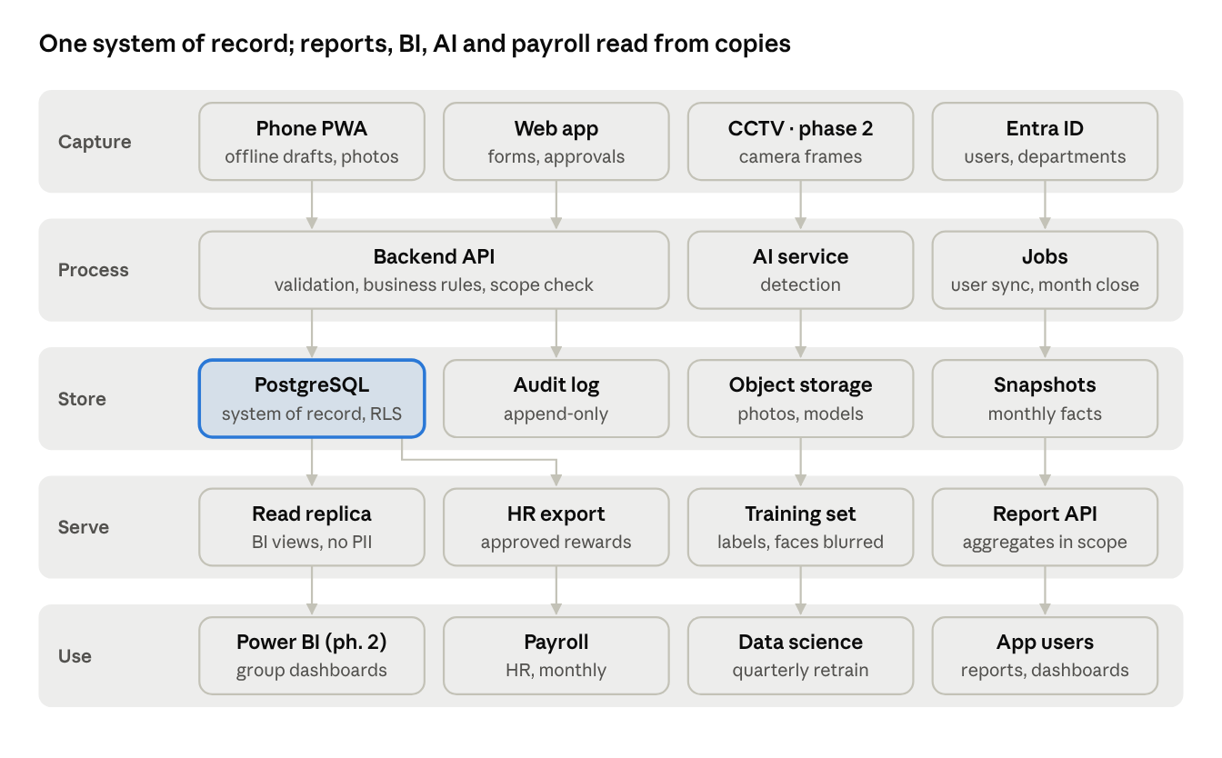
data architecture · 5 layers
Layers
Layer | Component | Holds | Rule
Capture | Phone PWA, web app | Drafts, photos, forms | Phone queues offline in IndexedDB; sync is idempotent on a client UUID
Capture | Entra ID | Users, email, department | Read only; nightly sync
Process | Backend API | No data of its own | Every write passes validation, business rules (PRD 4), role and unit scope; one transaction per action
Process | AI service (phase 2) | Model in memory | Reads frames and models; returns detections to the backend, never writes to the database itself
Process | Jobs | Schedules | User sync, overdue CAPA, month close, quarter and year close
Store | PostgreSQL | All business records (section 2) | System of record; row-level security by unit; point-in-time recovery
Store | Audit log | Every change with old and new value | Append-only, separate schema, no update or delete grant
Store | Object storage | Photos, model files, exports | Keys only in the database; versioning on; lifecycle to archive after 3 years
Store | Snapshots | Monthly facts per project and area | Written at month close; reports for past months read these, so history never changes
Serve | Report API | Aggregates per report and scope | Computes from snapshots plus current records; same numbers on screen and in Excel/PDF
Serve | Read replica (phase 2) | BI views | Views with no personal fields (names replaced by unit and role)
Serve | HR export | Approved reward lines of a month | File created by Finance only; hash and download logged
Serve | Training set | Confirmed boxes and corrections | Exported with blurred images and no names
Master data ownership
Data | Owner | Changed by | Versioned
Units, areas, zones | LEAN | LEAN admin, CI coordinator of the unit | Yes, effective date
5S question set, phase checklists | LEAN | LEAN admin | Yes, published sets are immutable
Approval matrix, reward parameters, budget lines | LEAN and Finance | LEAN admin with Finance approval | Yes, per fiscal year
AI classes and models | LEAN | PM or LEAN | Yes, model version
Users and departments | IT (Entra ID) | Entra ID only; roles in Kaizen App by LEAN | Change log
Key numbers and their lineage (so Dev, Finance and LEAN agree on one source)
Number | Comes from | Computed when | Shown in
5S score per area | audit_answer → audit.pct_* | Audit submit | 5S report, home, T4
Hard saving to date | project_month.saving_vnd confirmed by Finance | Month close → project_snapshot | Project page, BOD, rewards
Run-rate, EVM, quality score | project_month, phases, risks | Month close → project_snapshot | Progress report, BOD
Reward amounts | reward_line | Event or month close (Process & Data Flows 7.4) | Reward report, HR export
AI precision | ai_detection.review | On read | AI log, model registry
Integration principles: APIs and files only, no shared database; every integration has a named owner, a format version and a log; outbound files carry a checksum.

7. Data security policy
Kaizen App holds personal data of employees (names, employee numbers, photos where people may appear, individual reward amounts), so it falls under Vietnam's Personal Data Protection Law No. 91/2025/QH15 and Decree 356/2025/NĐ-CP, both effective 1 January 2026; the decree replaces Decree 13/2023/NĐ-CP (LuatVietnam, PwC Vietnam). This policy is a draft for Legal and IT security to confirm before go-live.

7.1 Ownership and roles
Role | Who | Responsible for
Data owner | Head of LEAN (P.SXTG) | Approves access rules, retention, sharing outside ProC
Finance data owner | Head of Finance (P.TCKT) | Savings, budget and reward amounts
Data steward per unit | CI coordinator of each unit | Master data (areas, zones, users), data quality
System custodian | IT department | Hosting, backup, patching, logs, incident handling
Data protection contact | Legal / DPO function of the group | Personal-data compliance, impact assessment, requests from data subjects

7.2 Data classification
Class | Examples in Kaizen App | Who may see it | Handling
Internal | Areas, zones, questions, 5S scores, quick ideas without names, aggregated reports | All signed-in users within their unit scope | Default class
Confidential | Project savings, investment, NPV, budget, unit-level reward totals, CAPA details | Roles per PRD 2, within unit scope | No export to personal devices except reports; watermark exports with user and time
Personal | Name, email, employee no., idea authorship, individual reward lines | The person, their managers in scope, LEAN, Finance, HR file | Processed only for the Lean program and reward payment; consent notice at first login
Restricted | Photos where people can be identified, AI scans with PPE classes, PIN hashes, audit log | LEAN admins and the area chain only; never in public reports | Faces blurred before upload; no face recognition; encrypted; access logged

7.3 Access control
- Least privilege: roles and unit scope per PRD 2; enforced in the API and by row-level security in the database.
- Single sign-on with Microsoft Entra ID and MFA for every role except shop-floor PIN accounts; PIN accounts can only submit ideas and see their own items.
- Admin rights (LEAN admin, IT) are named, reviewed every quarter by the data owner, and removed on role change or exit within 1 working day (nightly Entra ID sync deactivates leavers).
- Service accounts (jobs, AI service) use separate credentials stored in a secret vault, rotated every 90 days.
- No shared accounts; no production data in test environments unless anonymized.

7.4 Encryption and secrets
- In transit: TLS 1.2 or higher on every connection, including database and object storage.
- At rest: database and object storage encrypted (AES-256, platform-managed keys); backups encrypted.
- Secrets (DB passwords, API keys, LLM key) only in the vault, never in code, config files or logs.
- Photos served by signed URLs valid 10 minutes.

7.5 Photos, AI and GenAI
- Capture only what the 5S or safety finding needs; aim the camera at the place, not at people.
- Faces blurred on the phone before upload; the AI model has no person-identity classes and the system stores no biometric template.
- PPE results (no helmet, no vest) are recorded against the area and zone, never against a named person, and are not used for discipline.
- GenAI (5 Why, fishbone drafts): only problem text and area type are sent; no names, photos or money figures. The LLM provider must not train on or retain the prompts (contract clause); calls are logged.
- Model training data is exported without names; images keep the blur.

7.6 Retention and deletion
Data | Kept | Then
Audits, CAPA, projects, rewards, audit log | 10 years (to confirm with Finance and Legal) | Archive, read-only
Photos (audit, CAPA, ideas, AI scans) | 3 years | Moved to archive storage; deleted after 5 years
CCTV frames (phase 2) | Not stored unless a confirmed detection; then as photos | Unconfirmed frames deleted within 24 hours
User accounts of leavers | Deactivated at exit | Personal fields pseudonymized after 2 years; records keep the pseudonym
Backups | 30 days daily, 12 months monthly | Overwritten
A data subject may ask to see or correct their personal data through LEAN; deletion requests are handled by the data protection contact, balanced against the 10-year record duty.

7.7 Logging and monitoring
- Application audit log for every business change (section 5); security log for sign-ins, failed sign-ins, permission denials, exports and admin actions.
- Logs kept 12 months, sent to the group's monitoring tool; alert on 10 failed sign-ins per account in 15 minutes, bulk exports, and access outside working hours by admin accounts.
- Exports of Confidential or Personal data (Excel, PDF, HR file, YOLO labels) are logged with user, time and filter.

7.8 Backup, recovery and availability
- Daily database backup and object-storage versioning; recovery point objective 24 hours, recovery time objective 8 working hours.
- A restore test every quarter, recorded by IT.
- Phones keep unsent drafts encrypted in browser storage until synced; a lost phone is handled by revoking its session.

7.9 Incident response
- Anyone who suspects a breach (lost phone with drafts, wrong export, account misuse) reports to IT and LEAN the same day.
- IT contains it: revoke sessions and tokens, disable the account, block the export link.
- IT and the data protection contact assess what personal data was involved and how many people.
- If personal data was breached, notify the competent authority and affected people within the deadline set by Law 91/2025/QH15 and Decree 356/2025/NĐ-CP (Legal to confirm the exact timeline).
- Root cause and corrective action recorded as a CAPA in Kaizen App, reviewed by the data owner.

7.10 Vendors and development
- Any vendor (development team, hosting, LLM API, labeling service) signs a data processing agreement covering confidentiality, sub-processors, location of data, deletion at contract end and breach notice.
- Data leaves Vietnam only if Legal has approved the cross-border transfer and the required impact assessment is filed.
- Secure development: code review, dependency scanning, OWASP Top 10 testing before each release, and a penetration test before go-live.
- Developers work with seed or anonymized data; production access only through IT with a ticket.

8. Data schema
The physical schema for PostgreSQL 16 (enum types, tables, keys, checks, row-level security and triggers) is in the tab Data schema (DDL). It implements sections 2, 3 and 5; if they disagree, fix this doc first, then the DDL.

9. Email reports to leadership
Four tables carry the email feature (PRD 3.9, BPMN 7.5): subscriptions say what is sent to which roles and when, role_mailbox turns roles into addresses at send time, and every email is kept with its recipients and the HTML as sent. Delivery uses Microsoft Graph sendMail from a shared service mailbox.
Tables
Table | Field | Type | Rule
report_subscription | code, mail_type, trigger, send_time | varchar(10), enum, enum, time | One row per email type; send_time NULL only for Event
report_subscription | to_roles, cc_roles, extra_emails, requires_review, format, per_unit, skip_if_empty, active | role_code[], role_code[], text[], bool, enum, bool, bool, bool | To and CC roles never overlap; per_unit = one email per unit with that unit's data
role_mailbox | role, unit_id, area_id, email | enum, FK null, FK null, text | Mailbox per role and unit (or area); NULL unit = group mailbox for all units
email_message | code, subscription_id, origin, event_type, event_ref, unit_id, period | varchar(10), FK, enum, text, uuid, FK null, varchar(9) | Unique per (subscription, event, unit) and per (subscription, period, unit): an event or a period never sends twice
email_message | subject, html, text_body, pdf_file_id, note, status, reviewed_by, reviewed_at, attempts, last_error, sent_at | text, text, text, FK, text, enum, FK, timestamptz, smallint, text, timestamptz | Status Draft → AwaitingReview → Queued → Sent / Failed, or Returned; attempts ≤ 3
email_recipient | message_id, kind, role, user_id, email, graph_message_id | FK, enum To/Cc, enum, FK null, text, text | One row per address per email
Status machine of an email
From | To | Who | Guard
— | Draft | Kaizen App | Built by schedule, event or manual send; recipients resolved
Draft | AwaitingReview | Kaizen App | requires_review
Draft, AwaitingReview | Queued | Kaizen App, LEAN | No review needed, or LEAN approved
AwaitingReview | Returned | LEAN | Comment required
Queued | Sent | Kaizen App | Graph accepted the message
Queued | Failed | Kaizen App | 3 attempts failed; LEAN notified
Failed | Queued | LEAN | Manual retry
API
Method | Path | Purpose | Roles
GET | /mail/subscriptions | List subscriptions with next run time | All (read)
PATCH | /mail/subscriptions/{id} | Change roles, time, review, format, active | LEAN
GET, PUT | /mail/mailboxes | Role → mailbox directory | LEAN
POST | /mail/preview | {type, unitId?, auditId?, note?} → subject, HTML, resolved recipients, next run | PM, LEAN; unit-scoped roles for their unit only
POST | /mail/send | Same body; sends now or queues for review | PM, LEAN
POST | /mail/test | Same body; sends only to the caller | All
GET | /mail/messages | Send log, filters by status, type, unit, period | LEAN, PM
GET | /mail/messages/mine | Emails the caller received | All
GET | /mail/messages/{id} | One email with recipients and HTML as sent | Recipients, LEAN
POST | /mail/messages/{id}/approve, /return, /retry | Review and retry actions | LEAN
POST /api/v1/mail/send
{ "type": "BodMonthly", "note": "Tiết kiệm đạt kế hoạch nhờ CI-2627-001; đề nghị BTGĐ hỗ trợ ATN xử lý CAPA quá hạn." }
202 Accepted
{ "code": "EM-0042", "status": "Queued",
"to": ["btgd@<company domain>"],
"cc": ["gd.nhamay@<company domain>", "taichinh@<company domain>", "lean@<company domain>"],
"subject": "[Kaizen] Bản tin Lean tháng 10/2026: tiết kiệm 511 tr, 5S 76,8%" }
Email security rules (part of the Data security policy, section 7)
- Content follows the recipient's data scope; per-unit emails are built with that unit's scope set in the database session, the same as the app.
- Emails carry totals and links, never individual reward amounts, PIN, photos of people or raw AI images; the CTA link opens the app, which asks for sign-in.
- Header label shows the class (Internal, Confidential – Internal, Urgent – Internal); Confidential emails go only to internal addresses, and extra_emails outside the company domain are rejected.
- The service mailbox sends only (Graph application permission Mail.Send limited to that one mailbox by an Exchange application access policy); its secret is in the vault and rotated every 90 days.
- Sent HTML is kept 2 years for audit, then cleared, keeping subject, recipients and status.

